Curriculum and Instruction Announces
Parent Workshop Series

How has Common Core affected learning expectations?
What are the changes in the state assessment?
What is PARCC?

Audience: Parents/Guardians of students in grades 3 through 11
Location: Piscataway High School

Mark Your Calendar
Dates:
Part 1 of 2 – September 30, 2014
Part 2 of 2 – November 12, 2014

Time: 6:30 pm

Follow up Information Session: February 10, 2015
Information Session Review and Preview: April 22, 2015 (Grades 2 – 11)
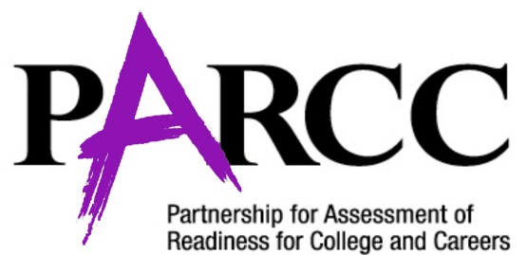
www.parcconline.org

